Student Name | G. Manasa
Student Registration Number | 241U1R3007 | Class &Section: CSE(DS)
Study Level: UG/PG | UG | Year &Term: I & II
Subject Name | Digital Electronics

Name of the Assessment | Reflective Journal -5
Date of Submission | 10/07/2025

Reflective Journal Template
Journal Entry Guidelines | Description
1. Experience (Class Content) | Briefly describe the topics or concepts discussed during the class.
2. Feelings (Emotional Reactions) | Share your emotional reactions and thoughts during the class.  How did you feel while learning this theory?  Did the class evoke specific emotions or questions?
3. Learning (Key Insights) | Reflect on what you learned from the class.  Highlight the key insights or fundamental concepts you gained from the class.
4. Application (Practical Use) | Describe how you plan to apply the theory you've learned in real-life situations or in your academic/career endeavours.  Explain the practical utility of this theory.

Sample Journal Entry

Date | 31-07-2025
Journal Entry Topic | Boolean Algebra  Postulates and Theorems, Constants, Variables and Functions, Switching Algebra
1. Experience (Class Content) | In this module we learned about Logic Gates was really interesting and eye-opening for me. I found out that logic gates are the basic parts that make all digital devices work, and they help computers “decide” things using binary (0s and 1s). The module had both theory and practical activities, which helped me see how Boolean logic is used in real electronic circuits. At first, I was a bit confused by all the different gates like AND, OR, NOT, NAND, NOR, XOR, and XNOR, and their truth tables. But once I learned how to match the inputs to the outputs, I started to understand and remember them better. What made it even cooler was seeing how you can actually build these gates in real life using things like transistors (BC107), diodes (IN4001), and resistors. Before, I only thought of gates as simple boxes in circuit diagrams or in programming, but now I know how they really work inside.  Next we learned about universal gates. I was amazed that just using NAND or NOR gates, you can create any other logic gate, even the basic ones. Making NOT, AND, and OR gates out of only NAND or NOR gates felt like solving a fun puzzle. This really helped me understand how you can create complex circuits using just a few simple parts.
2.Feelings (Emotional Reactions) | This module made me feel many things! At first, I felt a bit nervous and confused because there were so many types of gates and logic rules to learn. But as I kept studying, I became more curious and excited. When I saw how gates are made using resistors and transistors, it helped me understand how they actually work. It was really cool to learn that just a few small parts can make decisions, kind of like how our brain works.
3. Learning (Key Insights) | 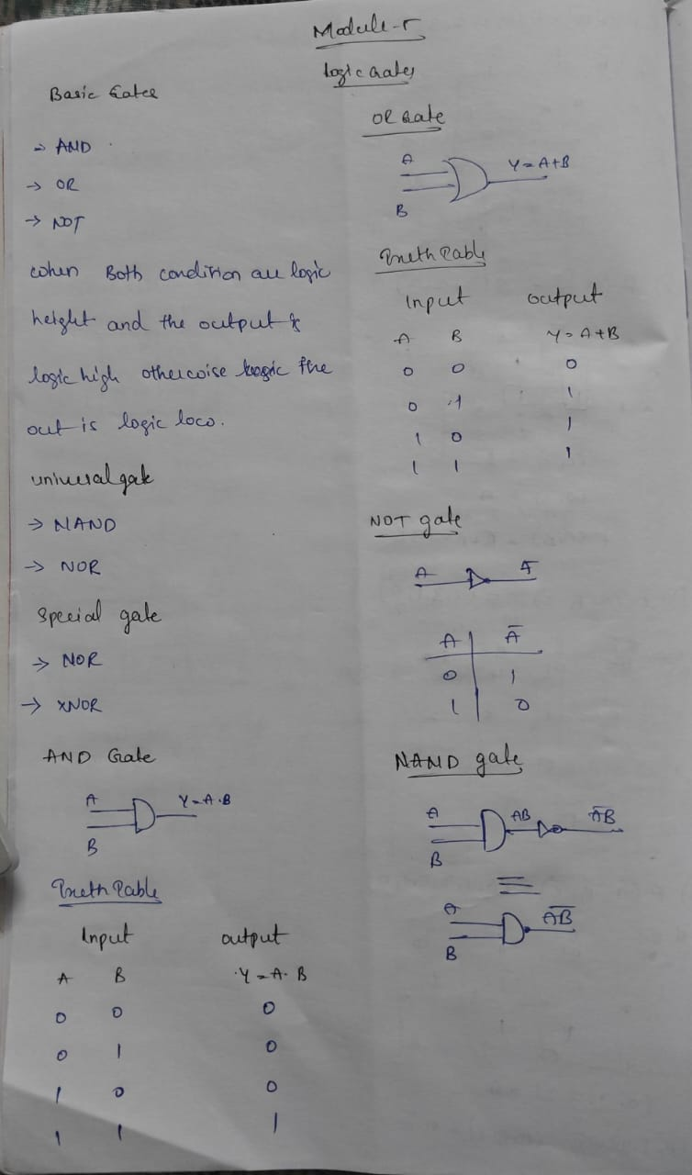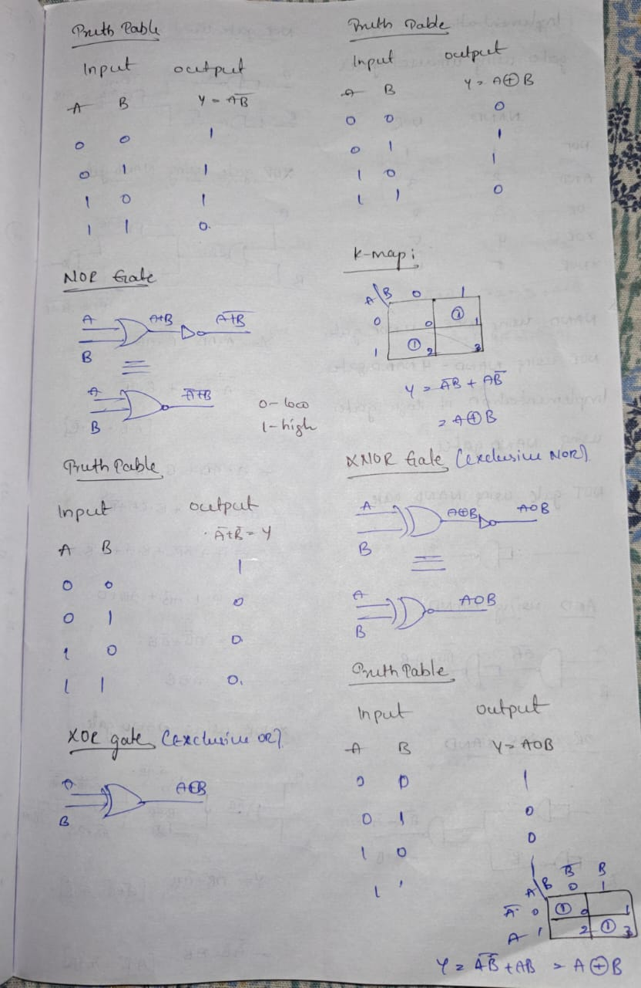  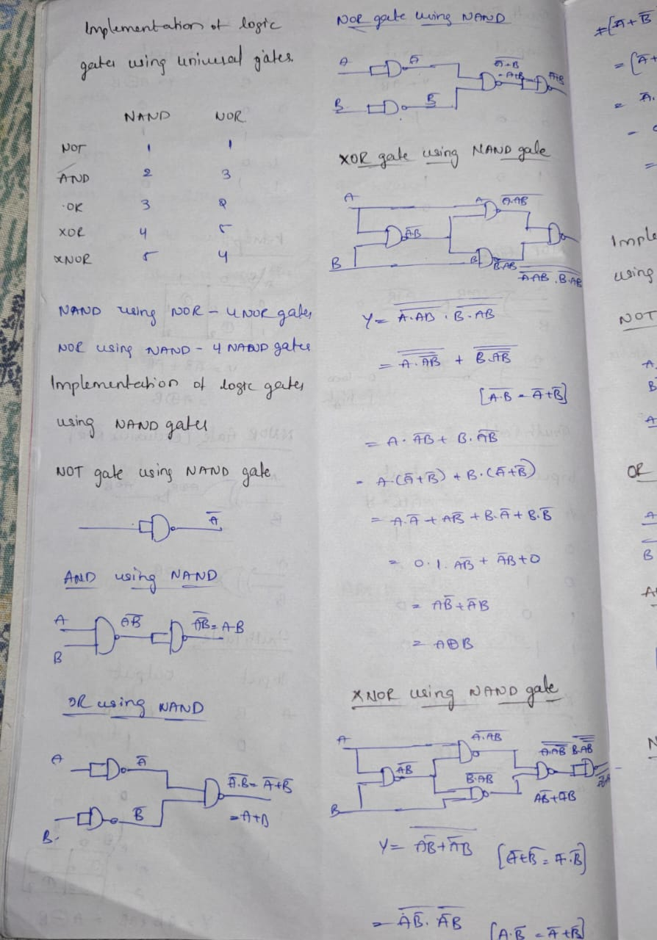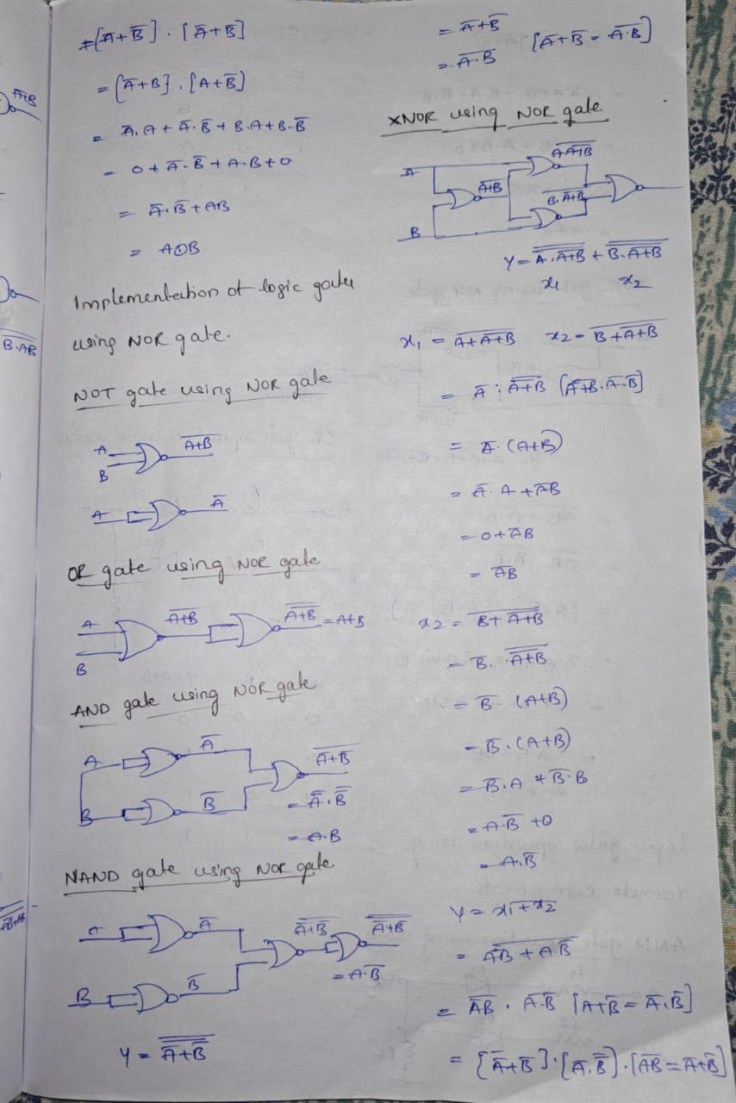  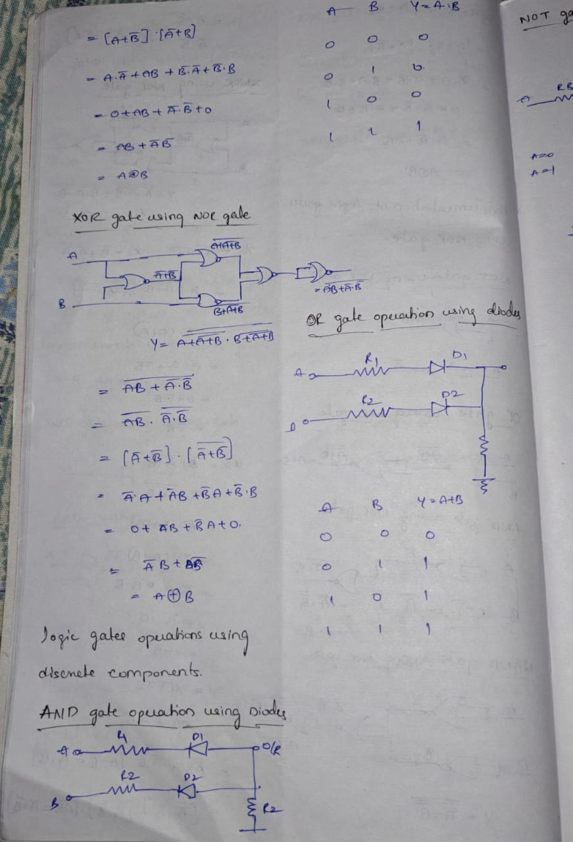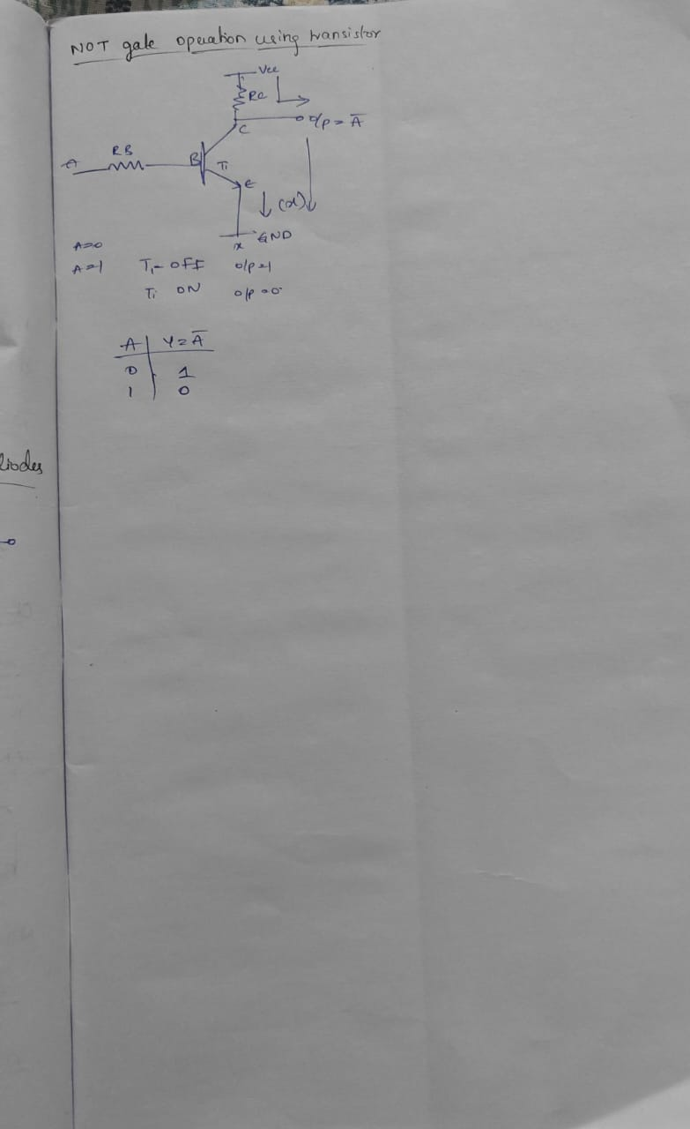
4. Application (Practical Use) | Digital Devices and Computers:  - Logic gates are used in almost every digital system, including microprocessors, memory devices, and ALUs (Arithmetic Logic Units).  - They form the base of binary addition, subtraction, decision making, and data comparison in CPUs.  Control Systems and Automation:  - Logic gates are used to build control circuits for smart devices such as washing machines, traffic lights, elevators, and security systems.  - They help perform decisions automatically based on sensor inputs.  Embedded Systems:  - In microcontrollers and embedded systems, logic gates are used for interfacing, timers, and control logic.  Troubleshooting and Repair:  - Knowing how gates are built from components helps in troubleshooting faulty logic circuits.  - It’s easier to detect which component (diode, transistor) might have failed.  DIY Projects and Circuit Design:  - Knowledge of discrete gate design is helpful for building simple electronic projects without ICs, useful in learning environments or resource-limited settings.  Digital Circuit Optimization:  - Understanding universal gates helps in designing cost-effective circuits by reducing the number of components or ICs used.
Conclusion | This module really helped me understand digital logic from start to finish. I didn’t just learn the theory and truth tables; I also got to see how logic gates are made using actual electronic parts. Before this, I thought of 1s and 0s as things I just read about, but now I can see how real devices use them to make decisions. What I learned isn’t just for exams or class it’s useful for real-life things like designing digital systems, building hardware, working with electronics, and making robots. This module gave me a strong base for learning more about digital circuits in the future, and it made me feel more confident about handling electronics. the most important thing I realized is that even the most advanced things like computers and phones are made from these simple logic gates. It’s cool to see how understanding the basics well can lead to creating really powerful and innovative things.

